


L
A
B

R
E
P
O
R
T

Course Code: Software Project Design Development
Course Code: CSE 416

Submitted To:
Dr. Mahfida Amjad Dipa
Assistant Professor, Dept of CSE
University of Information Technology and Sciences
Section:7B1
Batch:54
Submitted By:
Most. Samia zaman shammi | 0432320005101058
Sadia Islam | 0432320005101054
Fariha chowdhury | 0432320005101042

System modeling
1. Component Diagram
This Component Diagram highlights the high-level architecture of The World of Literature system by displaying its core software modules and their connections. It shows how components like user verification, book tracking, transaction handling, and inventory management communicate via interfaces to execute system tasks seamlessly.

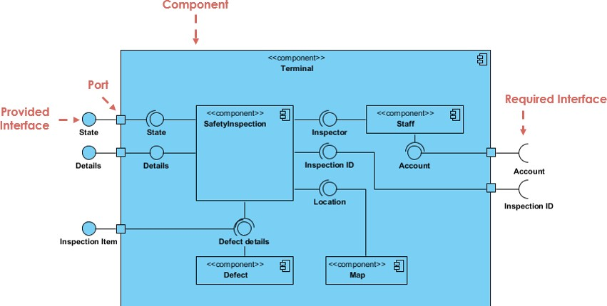

Activity Diagram

This Activity Diagram models the dynamic operational workflow of The World of Literature system, starting with user login verification. Upon reaching the main dashboard, users can navigate through four primary branches: searching for books, issuing books (with inventory availability checks and receipt generation), returning books (including fine calculations), and managing member profiles (adding, updating, or removing accounts). Each path concludes by returning to the main menu or logging out of the system.

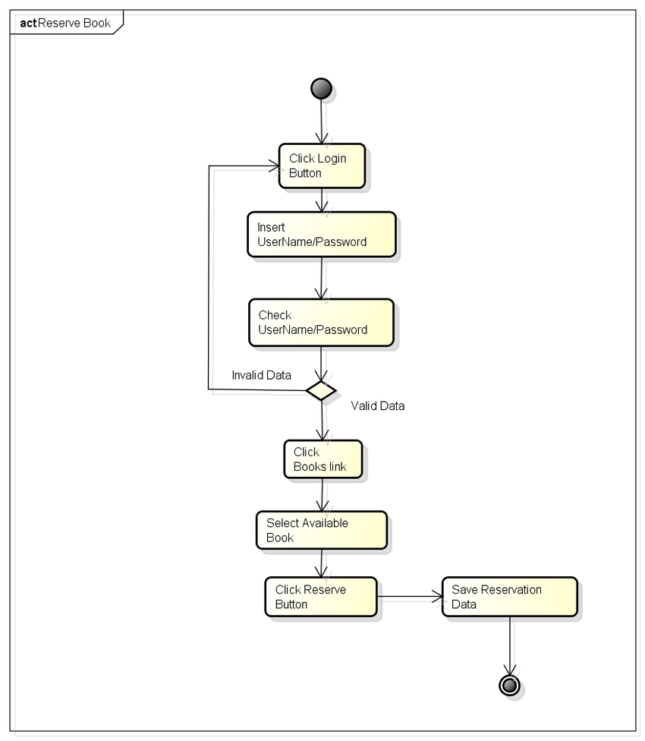

Sequence Diagram
This Sequence Diagram illustrates the step-by-step interactions involved in the book search and borrowing process within The World of Literature system. It shows how the User interacts with the system through the Library Interface to search for a book, which then prompts the Library System to check availability in the Catalog. Depending on the item's availability, the system either completes the borrowing request and updates the catalog status or notifies the user that the book is unavailable.
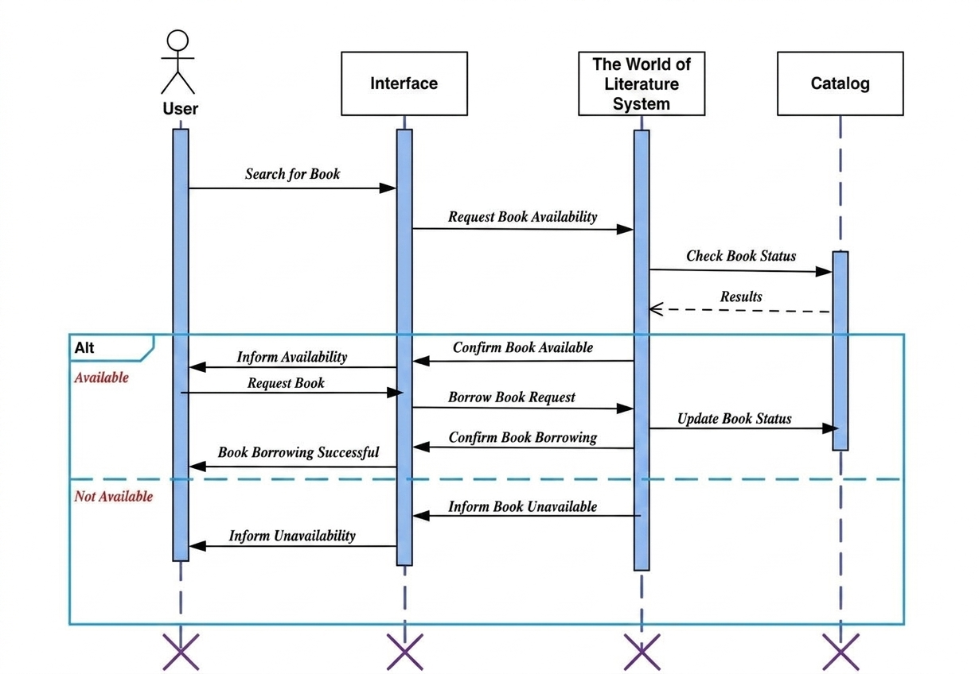

Fishbone Diagram
This Fishbone Diagram analyzes the root causes of system inefficiencies and user dissatisfaction in The World of Literature across six core areas: People (training, human error), Process (slow cataloging, complex checkout), Equipment/Technology (outdated software, network lag), Resources (funding, book shortages), Environment (cramped spaces, poor lighting), and Management (vague goals, inefficient policies).

